# Holland Township School Community Resources/Referrals List

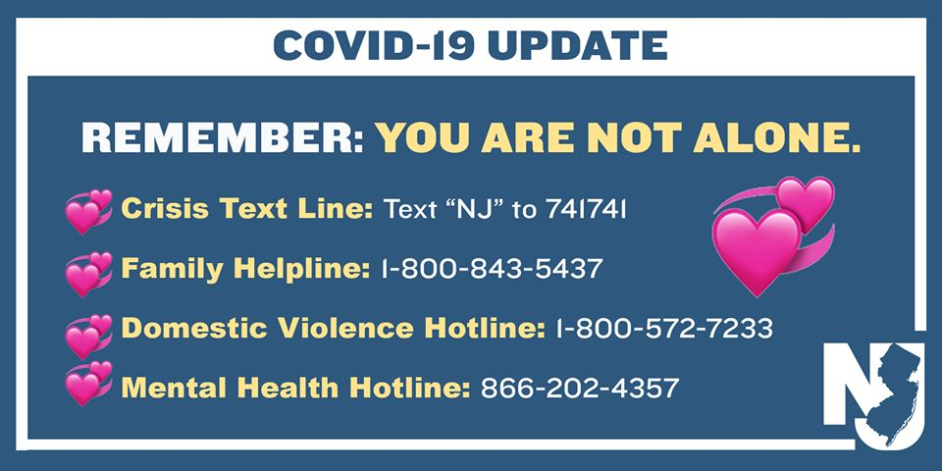

Crisis Intervention

**Perform Care/Children’s Mobile Response/Stabilization Services** 877-652-7624

Mobile Response and Stabilization Services are available 24/7, to help children and youth who are experiencing an emotional or behavioral crisis. The services are designed to defuse an immediate crisis, keep children and their families safe, and maintain the children in their own homes or current living situation (such as a foster home, treatment home, or group home) in the community.

**Hunterdon Medical Center/Hunterdon Behavioral Health**

**Emergency Mental Health Services** 908-788-6400

This number can be called if a child, adolescent, or adult is having suicidal or homicidal thoughts or a plan or if a student is a danger to themselves or others.

**Family Crisis Intervention Unit** 908-788-6401  
The Family Crisis Intervention Unit provides immediate crisis counseling to stabilize family crises, such as family conflict, runaways, threat to the juvenile's emotional and physical well-being and truancy.

Services are free and available 24-hours a day, 7 days a week.

**Family Support Organization of Hunterdon/Somerset/ Warren** Main Line: 908-213-9932

Warm Line: 908-223-1191

This organization ensures families of children with special emotional, behavioral or mental health challenges are provided with a compassionate, community-based, culturally-competent system of care that will provide Hunterdon, Somerset and Warren county with family-friendly support services, education and advocacy.

[www.fso-hsw.org](http://www.fso-hsw.org)

**2nd Floor Youth Helpline 888-222-2228** [www.2ndfloor.org](http://www.2ndfloor.org/)

2NDFLOOR is a confidential and anonymous helpline for New Jersey's youth and young adults ages 10 to 24. Students can text or call this number. They are available 24/7 365 days a year.

Community Counseling Services

**Catholic Charities** 908 -782-7905

6 Park Ave, Flemington, NJ 08822 [www.ccdom.org](http://www.ccdom.org)

**Hunterdon Behavioral Health** 908-788-6401

2100 Wescott Drive Flemington, NJ 08822 [www.hunterdonhealthcare.org](http://www.hunterdonhealthcare.org)

Hotlines

**Hunterdon Helpline** 908-782-4357

The mission of **Hunterdon Helpline** is to provide a 7-day a week initial assistance call center that receives, responds to, follows up and documents requests for assistance, provides information, referrals, advocacy and care management which address the needs within the communities we serve.

**Suicide Prevention Lifeline** 800-273-TALK

## Hunterdon Healthcare COVID-19 Hotline

Hunterdon Healthcare has created a hotline for the community to call in with questions regarding Coronavirus. The Hunterdon Healthcare COVID Hotline can be reached by calling 908-788-6440. The hotline will be open seven days a week, 8:00 a.m. – 8:00 p.m.

Update March 2020